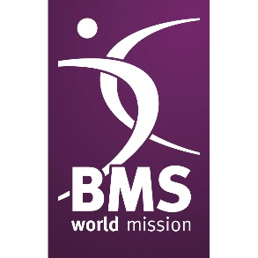
BMS World News
Issue 2/24

2023 – A YEAR IN REVIEW
From conflicts in Israel-Palestine to earthquakes in Nepal and Afghanistan, 2023 was marked by highs and lows. Despite these challenges, God has been faithful through it all, and the new year gives us an opportunity to celebrate the achievements of the BMS community. Here is a review of the most impactful events:

Transformed Lives in Thailand
The Thailand Spring appeal saw remarkable generosity, leading to transformed lives in south Thailand. Success stories like Thew and Suree’s food stall and Ajarn Arreat becoming a BMS-supported worker showed the power of your support. Five years ago, there were no believers in the region. Thanks to you there are now three blossoming churches!

A Season of Change in Chad
Guinebor II Hospital in Chad experienced significant changes with the departure of the Shrubsole, Chilvers and Spears families. Installation of new solar panels, partially funded by your generous giving, marked a shift towards sustainable energy sources.

Bringing Abundant Life in Uganda
Support for Days of Plenty empowered farmers like Barbara to overcome challenges and secure a better future, increasing their income and allowing their children to go to school.

Women on the Frontline of Climate Justice
COP28 highlighted the critical role of women in climate justice efforts globally. Your prayers for gender justice champions and activism against gender-based violence showed solidarity with those fighting for equality.

Hope Amid Disaster
Despite conflicts and disasters, your generous giving and prayers provided crucial support to affected communities. Displaced Armenians and earthquake-stricken regions received aid, and your prayers are still making a difference in the Israel-Gaza conflict.
Thank you so much for the transformation you’ve brought to 2023. It would not be possible without you. Your support will help more people across the world hear the good news about Jesus!
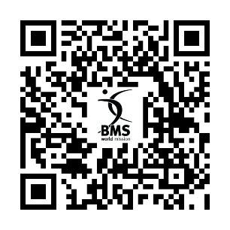
See how your support has helped change the world.

God’s love everyday: ukraine ten years on

Ten years, not two. That’s how long it’s been since Russia invaded Donetsk and Luhansk in Ukraine. You have stood with Ukrainians and their neighbours for the last ten years – and you stand with them now. Imagine fleeing from shelling to a temporary shelter, relying on the kindness of strangers. Everything you knew left behind, blitzed. And then winter. Winter bites hard in Ukraine. But your support is bringing warmth, help and hope to Ukrainians.

Since December, the Russian bombardment has left 3,000 families homeless. Millions of Ukrainians haven’t access to clean water and electricity, and one third of Ukrainians are unable to heat their homes during a -15°C winter.

Thanks to your support churches are opening so that people have somewhere warm to stay, providing hot meals and hygiene items. Even in the depths of this terrible war, you are helping Baptist churches bring hope to the people of Ukraine.

BMS World Mission also supports a refugee centre in Chisinau, Moldova. One of the women was 71-year-old Valentina, who fled the city of Kherson after two missiles destroyed her home. If she hadn’t been out, she likely wouldn’t have survived. Tears streamed down her cheeks as she shared her story, expressing a deep sense of hopelessness.

The church was able to offer Valentina a listening ear, comforting words, and prayer. They also directed her to a Christian counsellor who could guide her on her journey of healing. Despite her challenges, Valentina finds strength in living with her granddaughter and grandchildren. She left the refugee assistance centre encouraged, with a glimmer of hope in her eyes.

Our partners are deeply grateful for your support. Your faithful prayers and generous giving enable them to reach out to hundreds of families every month. Pray for churches and volunteers who selflessly give time to support refugees, for those who hear the gospel to become followers of Jesus, and for peace to prevail in Ukraine.

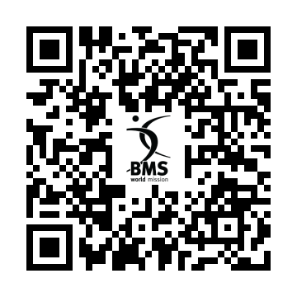
Discover how you’re making a difference in the wreckage of war.

STEPPING OUT IN FAITH

BMS worker Michele Mahon embarked on a challenging journey to the Awahun people in the Peruvian Amazon, involving a 17-hour bus ride, a five-hour boat journey, and an hour-long hike through dense rainforest.

In 2023, Michele, along with her husband Dave and their three children, moved to Trujillo, Peru. God gave Michele the opportunity to teach theology to the Awahun people – an indigenous group of fishermen, farmers, hunters, and artisans who live near the Ecuadorian border. Michele worked alongside Raquel Leon, a dedicated mission worker among the Awahun. Raquel despite being widowed continues her ministry, even selling coffee and cocoa from Awahun farmers to support her work.

The ministry’s focus shifted from material aid to teaching the Bible. The pastors hungered for God’s Word, seeking guidance on various topics. Michele emphasised proofs of God’s existence through creation and the innate knowledge of God within us.

Despite challenges like heat and mosquitoes, Michele and her team journeyed to Kuyumatak village, where pastors eagerly listened to Michele’s teachings. The ministry aims to reach both men and women, acknowledging the vital role women play in their community.

Michele admires Raquel’s leadership and continues to serve alongside her, spreading the gospel and fostering abundant life in Christ among the Awahun. The Mahon family values your ongoing prayers and support as they navigate their new life in Trujillo and share God’s love with those around them.

Thank you for all your prayers and support for Dave and Michele during their time in Peru. They would love for you to keep praying for them and their children, Ruth, Jonathan, and Phoebe, as they settle into life in Trujillo. It’s only in God’s strength that they can share his love freely with those around them.
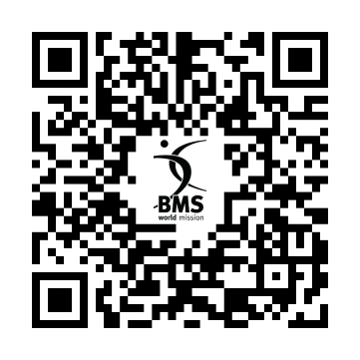
Find out more about the incredible work unfolding in Peru!

PENTECOST – BAPTIST ASSEMBLY 2024

Have you got your tickets for Baptist Assembly 2024?

We’d love to see you there! Come join us in Telford from the 17th – 19th May.
Come and connect with other Baptists from across the country as we worship, pray and unpack the incredible story of Pentecost.

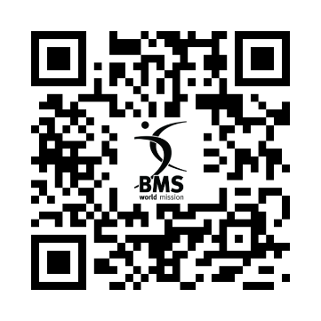
Scan the QR code to grab your tickets.

Editor: Ed Axtell
Tel: 01235 517700
Email: worldnews@bmsworldmission.org
BMS World Mission, PO Box 49, 129 Broadway, Didcot, Oxfordshire, OX11 8XA
Tel: 01235 517700 Website: www.bmsworldmission.org

The Baptist Missionary Society: registered in England and Wales as a charity, number 1174364 and a company limited by guarantee, number 10849689.

