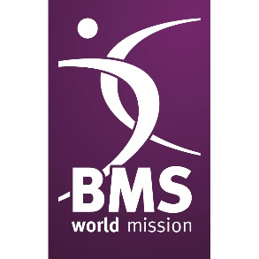
BMS World News
Issue 1/24

reflections on cop28
Back in December, we asked you to pray for COP28, the United Nation’s annual conference on climate change.

Please keep standing with others around the world and keep praying for communities impacted the most by environmental degradation and the effects of climate change.

Pray for young people around the world to have hope in God for their futures and to become leaders in their communities who will pave the way in restoring the damage done to God’s creation.

Pray for the women in Uganda and around the world who are dependent on firewood and wells for the daily needs of their families, especially as these resources become more difficult to access due to deforestation and climate change. We pray for peace and collaboration in their communities.

Pray for those at risk of domestic violence, exacerbated by the pressures of climate change and poverty. Pray that God’s justice will flow, and that in the face of climate breakdown, people will still be treated with respect and dignity.

Women in the world, irrespective of geographical and territorial boundaries, social status, or age, have been affected in many ways by environmental crises.
Please pray that God may provide comfort, refuge, and guidance to overcome the difficulties women are facing knowingly or unknowingly, through careful stewarding of creation and adaptation and mitigation responses and strategies.

We thank God that improving the environmental sustainability at Guinebor II Hospital, Chad also means that pregnant women and their babies can benefit from improved treatment conditions.

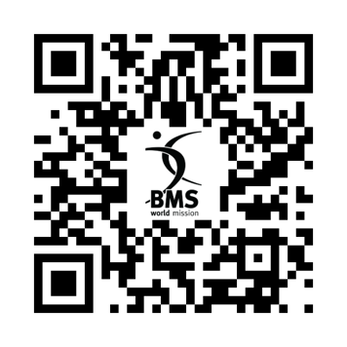
Discover more about how climate change and global warming are affecting communities around the world.

Thailand: Mission in Bloom

Your support of the Thailand Spring appeal has brought incredible change to believers in Thailand. You heard about the amazing work of Helen and Wit Boondeekhun in the appeal, let’s revisit the blossoming mission bearing fruit in Thailand and the change that you’ve
made possible.

Thew and Suree, Wang Daeng’s first believer, have recently launched a food stall outside the church. Their stall selling fried chicken, sticky rice and fried dumplings has been immensely popular in the community, especially with the children on their way to school! With every dumpling, you’re helping Thew provide for his family, build community, and draw newcomers into church with an inviting (and delicious!) welcome.

When Helen and Wit first came to Thailand, there were no churches or Christians in the region. But now, there are three blossoming churches. These churches started off as small house groups but have grown into community hubs of connection. They’re providing free English classes, local council representation and trying to support and meet the needs of the community.

With the amazing growth of the churches, God has been building up new workers for his harvest. Ajarn Arreat has become a BMS World Mission-supported worker, thanks to your generous giving. Ajan has been working as an English teacher and helping plant a church in Ban Dara.
Your support for Ajarn means she can focus her attention more fully on supporting the church, instead of juggling teaching jobs alongside.

“The harvest is great, but the workers are few.” The stories of lives transformed, hope restored and God’s Kingdom coming in Thailand are plentiful, much like a tree heavy under the weight of its own fruit. The harvest is plentiful, and this is only the beginning for Thailand.

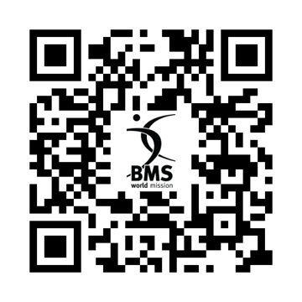
Uncover more of the fruit blossoming in Thailand.

NEW PLAYGROUND PROVISION FOR HOPE HOME’S CHILDREN

Please pray for BMS World Mission partner Hope Home as its children await the provision of an accessible playground. The residential home in Thailand, which supports children and young adults with disabilities and complex needs, has placed a downpayment on an empty plot of land next door, planted with banana trees.

BMS worker Judy Cook hopes that the playground will be a stimulating and fun environment for the children, where they can play and exercise in whatever way suits them best. Judy’s already planning sensory spaces for the home’s children based on their preferences and needs. With the purchase due to complete soon, the land needs to be cleared and levelled, after which the dreaming can really begin. A scoping visit to an accessible playground in the UK has given Judy inspiration for how to recreate elements using local materials or bamboo, and a conversation with a green-fingered local means a plan to involve the children in gardening could, God willing, one day bear fruit.

“We could eat our own vegetables,” says Judy, “and if we grew enough, maybe we could even have a little market stall.”

Seeing a member of the local community come alongside Hope Home’s children is just as exciting as imagining new ways for the children to flourish – part of Judy’s prayer to see them be ever more accepted in Thai society. The desire to see Hope Home’s children integrate well becomes more pressing the older they grow. With limited opportunities in Thailand for adults with complex needs, Judy is already thinking ahead to a day when the land could accommodate a support unit for adults with disabilities. “Huge thanks for your support: financial, but also prayers and encouragement,” Judy says. You’re ensuring a future where these children, and one day, adults, have the best quality of life possible. Thank you.
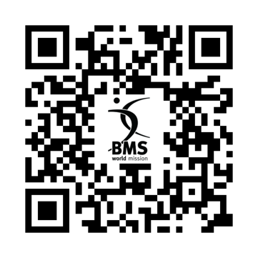
Learn more about the incredible work of Hope Home in Engage, the BMS magazine.

BECOME A 24:7 PARTNER

Do you want to share the good news of Jesus?

Do you want to stand against injustice and suffering?

You can do all of this and more by becoming a 24:7 Partner. 24:7 Partners commit to giving monthly and praying regularly, partnering in God’s mission to transform the world through Jesus.

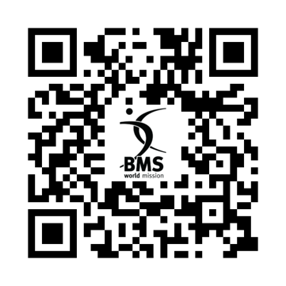
Scan the QR code to find out more.

Editor: Ed Axtell
Tel: 01235 517700
Email: worldnews@bmsworldmission.org
BMS World Mission, PO Box 49, 129 Broadway, Didcot, Oxfordshire, OX11 8XA
Tel: 01235 517700 Website: www.bmsworldmission.org

The Baptist Missionary Society: registered in England and Wales as a charity, number 1174364 and a company limited by guarantee, number 10849689.

